|  |  |  |  |  |
| --- | --- | --- | --- | --- |
|  | **Criteria** | **Grade claimed** | **Supporting arguments** | **Supporting evidence (refer to appendix if needed)** |
| **Basic** | Professional Behaviour | D | Being a team leader need to be professional and respectful so that all members fealt appreciated and involved in a professional environment.  As a team leader I had to host meetings and coordinate professional communication between the team and stakeholders of the project, eg. Product owner, supervisors, and expert panel. | Scheduling weekly / fortnightly meetings with team and product owner.  Taking notes from meetings with product owner for task creation, feedback and removal suggestions from product owner. Notes in appendices. |
| D | I oversaw project management, which meant that I actively updated the trello board so that members will not impede on others work. This meant that myself and the team progressed projects without any setbacks or confusion.  I hosted meetings with members and demonstrated how we will be commenting, tagging, assigning and communicating using trello and Microsoft teams. Now the team actively communicate over the project management tool. | Trello board can be found in the appendices section, listing the updates that were completed by myself and the team.  (<https://trello.com/b/gNlzJ7ax/escape-room-game-the-island-trello>) |
| Accountability (Worklogs) | D | Currently I have committed 85.9 hrs of work to the project. As such, this means I am on-track in hitting above 120 hours of work by the end of the semester. | Worklog with all my commitment and hourly progress can be found using the link in the appendices section. |
| Attendance | D | My attendance is currently at 100 percent attendance rate. This is so high because I am a team leader so it is essential to attend meetings as well as leading members. As such, this means I am adhering to the 90% or greater attendance rate. | Attendance log link can be found in the appendices section. |
| Engagement | D | I was actively involved in the team activities as I was the member primarily creating them and assigning them to members interested in completing those dedicated tasks.   I was also monitoring each task in trello so I can see the progress of each task in meeting iteration objectives.  I also arranged trello in the format that the team was able to tell identify the future tasks as well as the tasks planned in the next iterations. | Please refer off trello board in appendices.   Please refer off the communications shared between me and the team in terms of my engagement. |
| **Core** | Communication | HD | Actively communicated with all stakeholders of the project. These stakeholders included the development and design teams, the product owner, academic supervisors, and expert panel. I hosted and scheduled meetings so that all stakeholder could liaison and communicate with each member. Being able to hold all communication channels, myself and the team were able to easily discuss all project deliverables in depth and delivered information effectively to outside sources with ease. | Please refer off the continuous communication and discussion from myself to the team in the Microsoft team’s channel with updates to meet project deliverables. |
| Teamwork | HD | As a team leader I was providing continuous support to all members of the group. I had multiple peers reaching out to me to request support. I happily did this via messaging and through our discord channel. Whenever someone wanted to chat, I’d be in the channel.   I additionally held multiple informative sessions with juniors wishing to learn how to do the individual retrospective. I happily ran them through what needs to be summarised as well as the process of explain and providing evidence to committed work. | Please find examples of the ongoing support in Microsoft teams and discord. |
| Process | D | As a senior is it was up to me to walk the juniors through following the processes of fetching, pulling, and pushing to the dedicate branches aswell as following updates. This was the same process and contributions that I followed and as such allowed each member and myself to work as effectively as possible without risks of merge conflicts. | The processes and procedures were followed correctly. Please refer off our SourceTree repo. Bitbucket link with listed commits can be found here: |
| Product | HD | Committed a pluthera of tasks within this iteration which contributed towards the meeting design deliverables whilst also following the correct process. I had created new 3d animal models, rigged the models and also animated them based on their characteristics. Eg. Bird will fly, Snake will slither, and rat will run.  As such I also created new graphics for attacker messages that display on the screen whilst also creating new icons for the game with Arsha. All these tasks took more than 40 hours to complete, however the continuous contribution to the group accelerated towards completing the project and its design deliverables. | Please refer of all completed deliverables in appendices.   All contributions can be found within bitbucket under the 2021_T1_ Design branch.   My completed work consists of animating the UI so Title bounces up and down, menu buttons bounce on touch, new slick dynamic button designs, Animal creation, rigging animation, warning graphics, and icon design and implementation in installation. |
| D | As a team leader I am expected to participate significantly in team discussion especially when speaking to the expert panel and other stakeholders. As such, I have been happy to answer any questions that were thrown my way and happy to receive constructive criticism to be the quality of the app. | Evidence of this commitment to the project discussion can be found in the weekly meetings between myself and the team as well as in the previous academic supervisor meetings with myself, Yong, and alexander. |
| IT Skills | HD | I provided exceptional IT skills relevant to my unit by animating animals with ease as well as creating info graphics and warning messages when an attacker approaches the player. As such, I have proven my excellence in my design skills by providing quality work. | The exceptional design work I completed can be found in the Product Screenshots in the appendices section. Additionally, the videos of working animations can be found in the squad iteration 1 presentation. |
| **Advanced** | Self-Awareness | HD | I was able to identify my strengths using blender and animations and as such implemented this into creating successful design work. Now the snake slithers, the bird flies and the rat runs realistically. | This design work can be found in slides 10 – 13 of the squad iterations slides. |
| Project Management | HD | I participated wonderfully when maintaining the project and its progress. As such, any new ideas, I created in trello as new cards. I assigned corresponding members based on their upskilling behaviour and assigned the labelled group to complete the tasks, eg Development team, design team, etc. I also assigned story points for the degree of time and difficulty it’ll take for completion of that task. | Please refer off the trello screenshot within the project management section in appendices. |
| Mentoring | HD | Provided exceptional mentoring help by showing other juniors how to complete an individual retrospective, how to animate using blender, how to use photoshop effectively. | A lot of this was completed in discord over joining a channel for discussion, however evidence can be found in our last Thursday 7pm meeting recording. |

*My goals for the next iteration is to completely import all the attacker 3d models and animations to replace the original rat , bird and to add in a snake. I am planning to also create another animal in which is a low poly spider. I would love to learn how to animate a spider and to recreate its crawling style and have that imported into the game. I would also love to assist implement audio into the 3d cinematics as well as provide further exceptional project management.One thing I wish to improve on further includes adding in my own custom C# script so videos can be played via youtube in the how to play scene scene without removing users from the game entirely. This is just some of the hard objectives I am wishing to achieve. By the end of the next iteration. We are continuously creating new tasks from peer students, the product owner, academic supervisor, and the expert panel. I am looking forward to innovating the game further with the team.*

Appendices (if any)

# Professional Behaviour:

* + Professional note taking from product owner meetings.

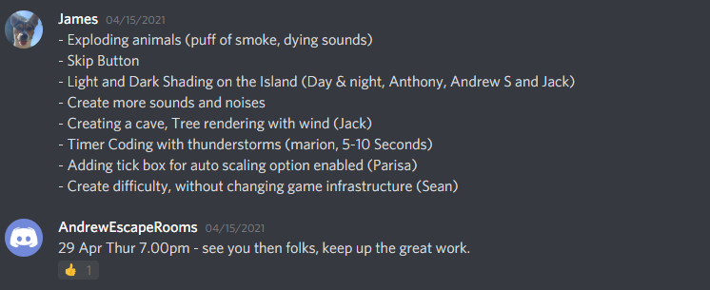

* + I oversaw, trello and thus was in charge of having an organised trello so work is not impeded and so the team can effectively progress tasks by being up to date. <https://trello.com/b/gNlzJ7ax/escape-room-game-the-island-trello>

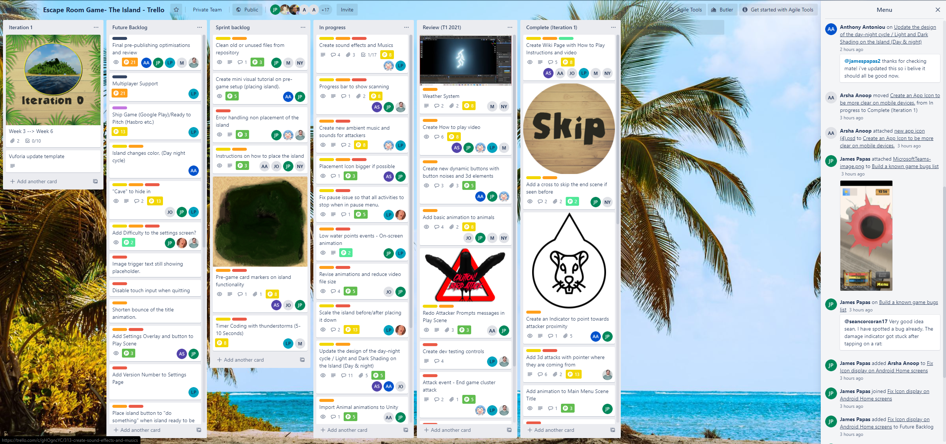

# Accountability

* Worklog was essential to monitor commitment in hours and to measure progress over time.  
  <https://deakin365.sharepoint.com/:x:/r/sites/DeakinCloudVentures/Shared%20Documents/Escape%20Room%20Games%20-%20The%20Island/Trimester%201%202021%20-%20Work/Worklog%202021%20T1.xlsx?d=wdb4a73bb88274b229939e8a593b1ea2b&csf=1&web=1&e=AeKYTJ>  
  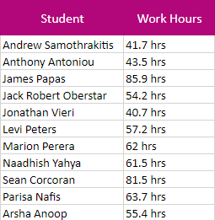

# Attendance

* Attendance log of attending meetings with team, product owner, academic supervisor, and expert panel. [https://deakin365.sharepoint.com/:x:/r/sites/DeakinCloudVentures/Shared%20Documents/Escape%20Room%20Games%20-%20The%20Island/Trimester%201%202021%20-%20Work/Group%20Attendance%20Log%202021.xlsx?d=wdcf04d66d50e4cbca4c9a882c6e2388d&csf=1&web=1&e=pF3gjB](https://deakin365.sharepoint.com/:x:/r/sites/DeakinCloudVentures/Shared%20Documents/Escape%20Room%20Games%20-%20The%20Island/Trimester%201%202021%20-%20Work/Group%20Attendance%20Log%202021.xlsx?d=wdcf04d66d50e4cbca4c9a882c6e2388d&csf=1&web=1&e=pF3gjB%20)

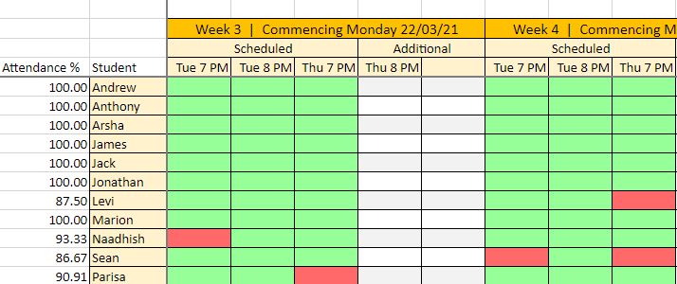

# Engagement

* My engagement in Microsoft teams, further engagement in activities and project planning can be found in the group trello board. 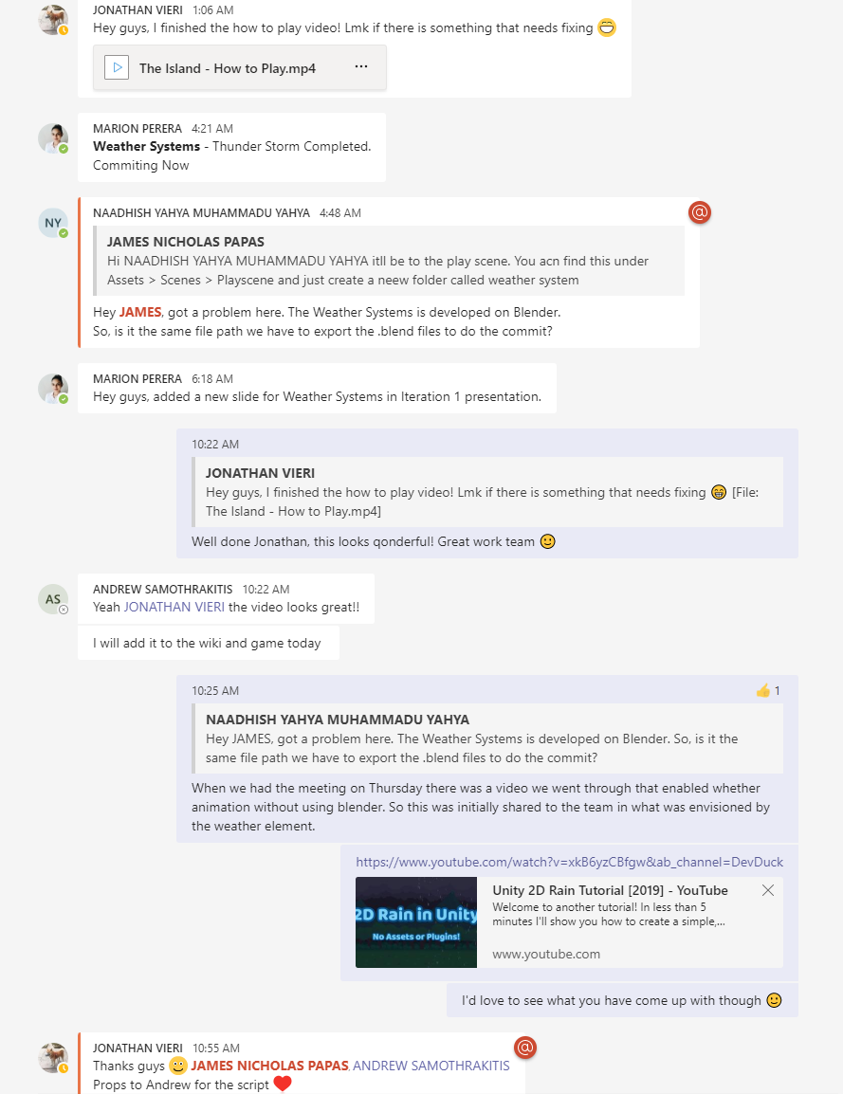

# Communication

* Communication transcript between myself and the team. This information was additionally shared with product owner and academic supervisor. As such, there was continuous updates from my end.   
  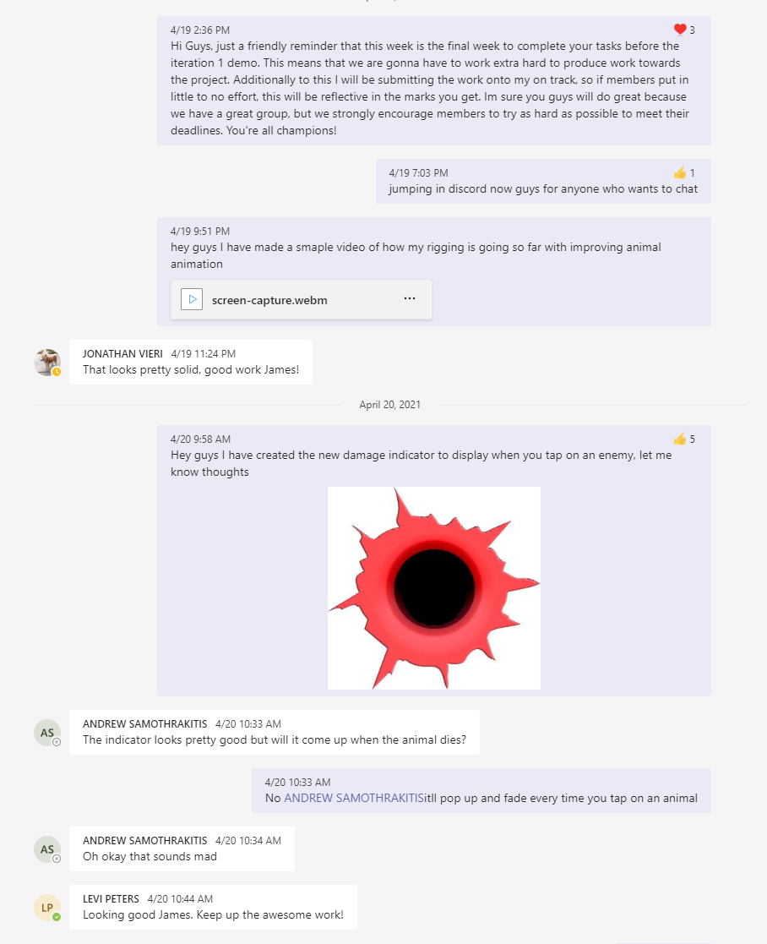

# Teamwork

* Provided outstanding support to other students in the team.

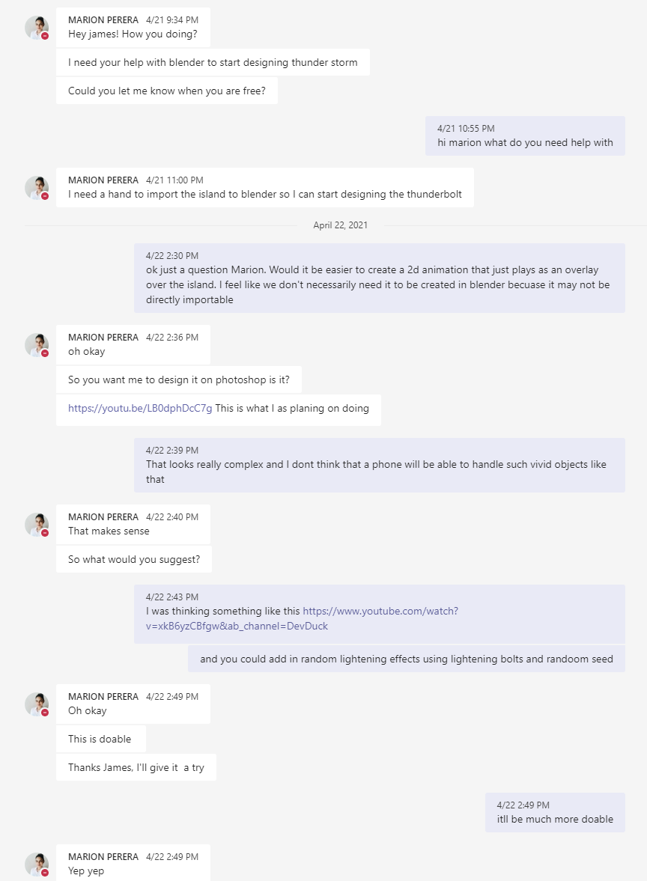

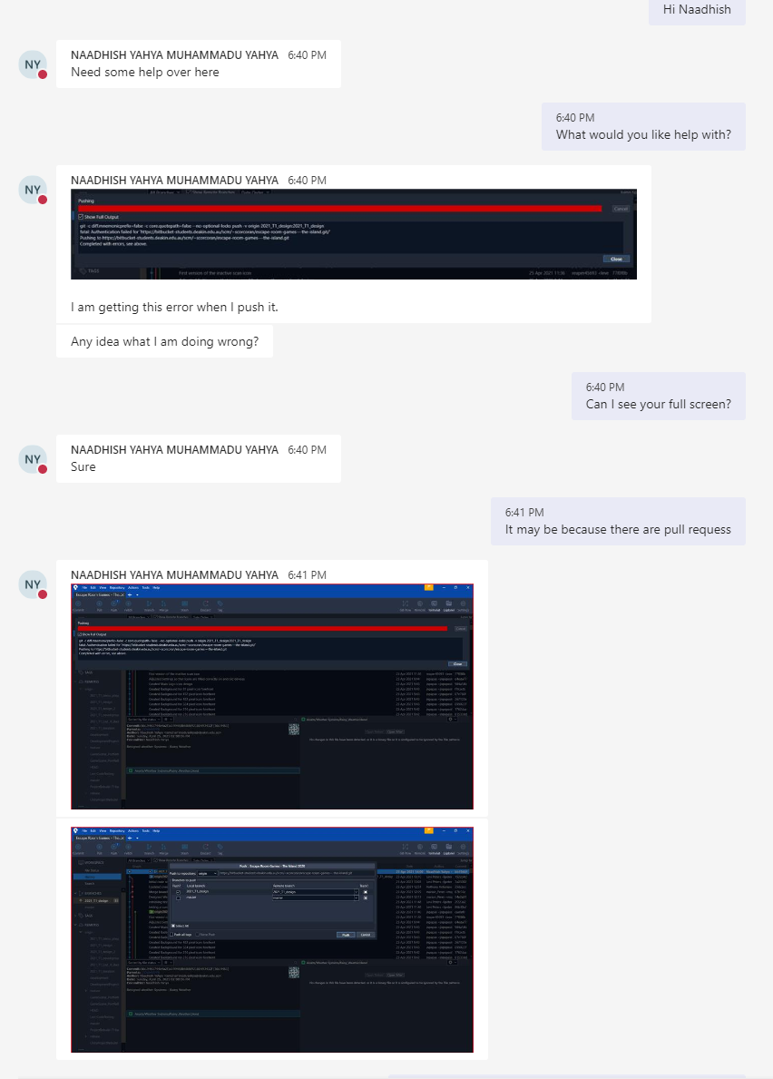 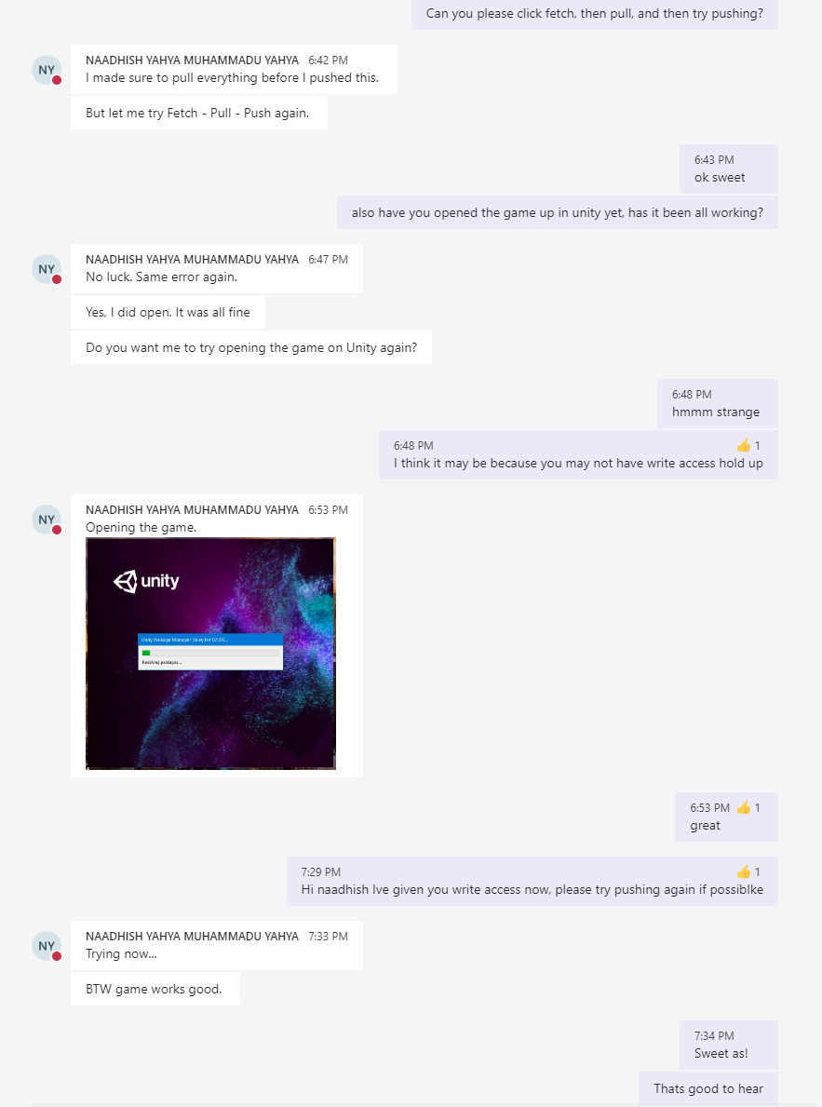

# Process

* The processes were followed between sourcetree and trello. Whatever myself and the team completed and committed to the project was also commented on and attached in the trello card. <https://bitbucket-students.deakin.edu.au/users/scorcoran/repos/escape-room-games---the-island/commits?until=refs%2Fheads%2F2021_T1_design&merges=include>

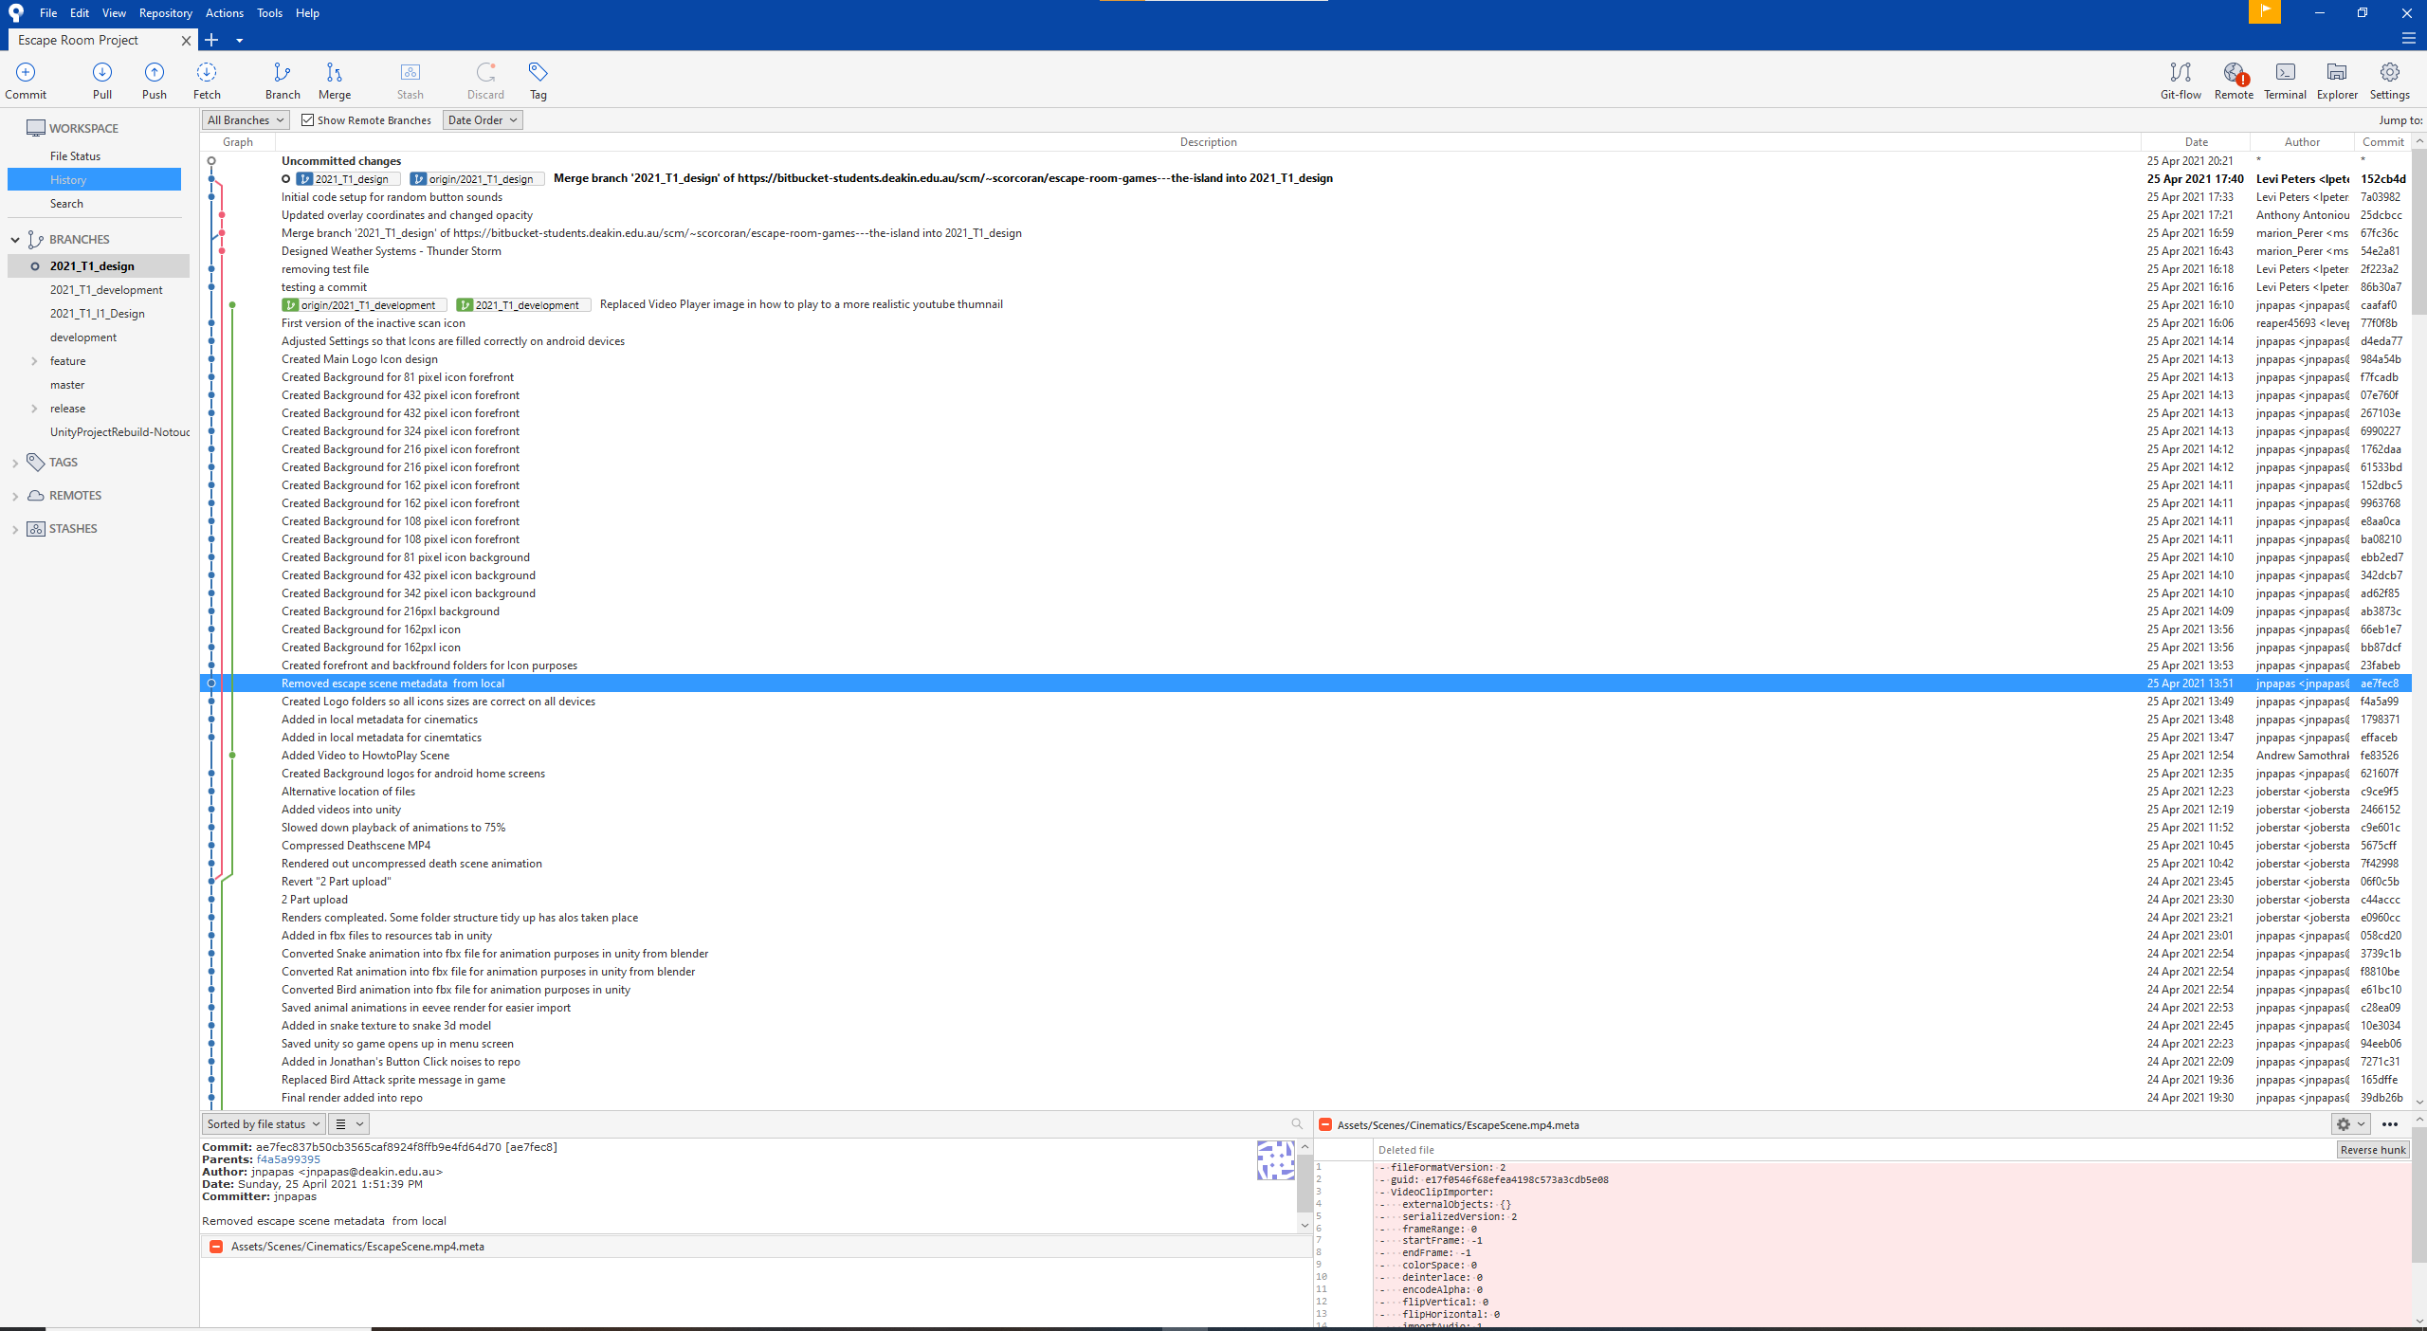

# Product

* The tasks I independently completed are listed from slides from slides 10 – 13 in squad retro ppt. <https://deakin365.sharepoint.com/:p:/r/sites/DeakinCloudVentures/Shared%20Documents/Escape%20Room%20Games%20-%20The%20Island/Trimester%201%202021%20-%20Work/Iteration%20Presentations/Iteration%201.pptx?d=waf87d545afe842838dc71679365c6a26&csf=1&web=1&e=fEhYcT>

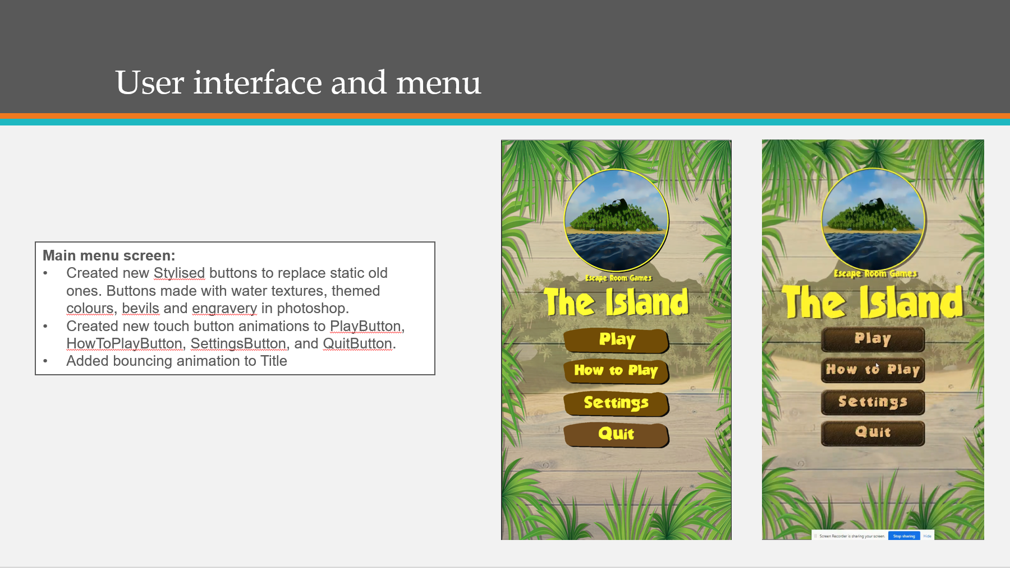 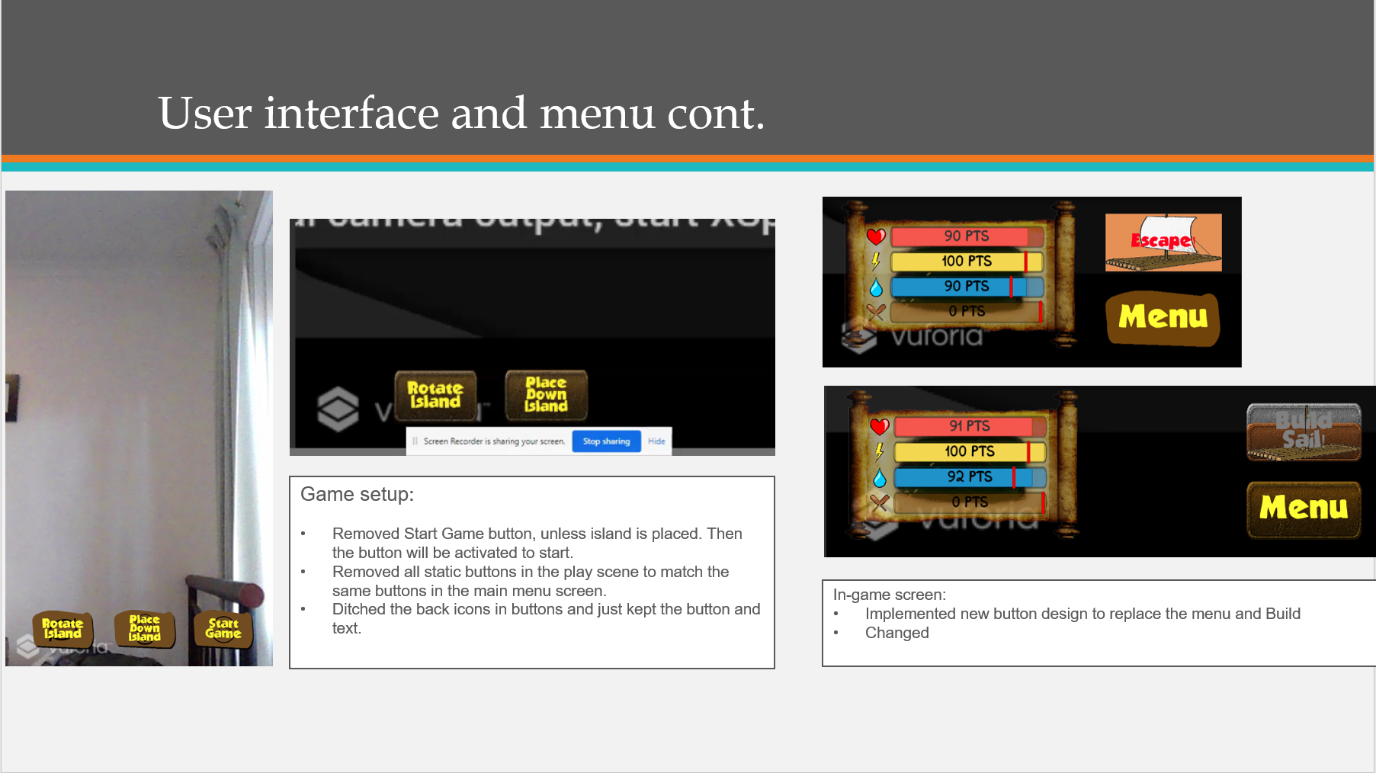

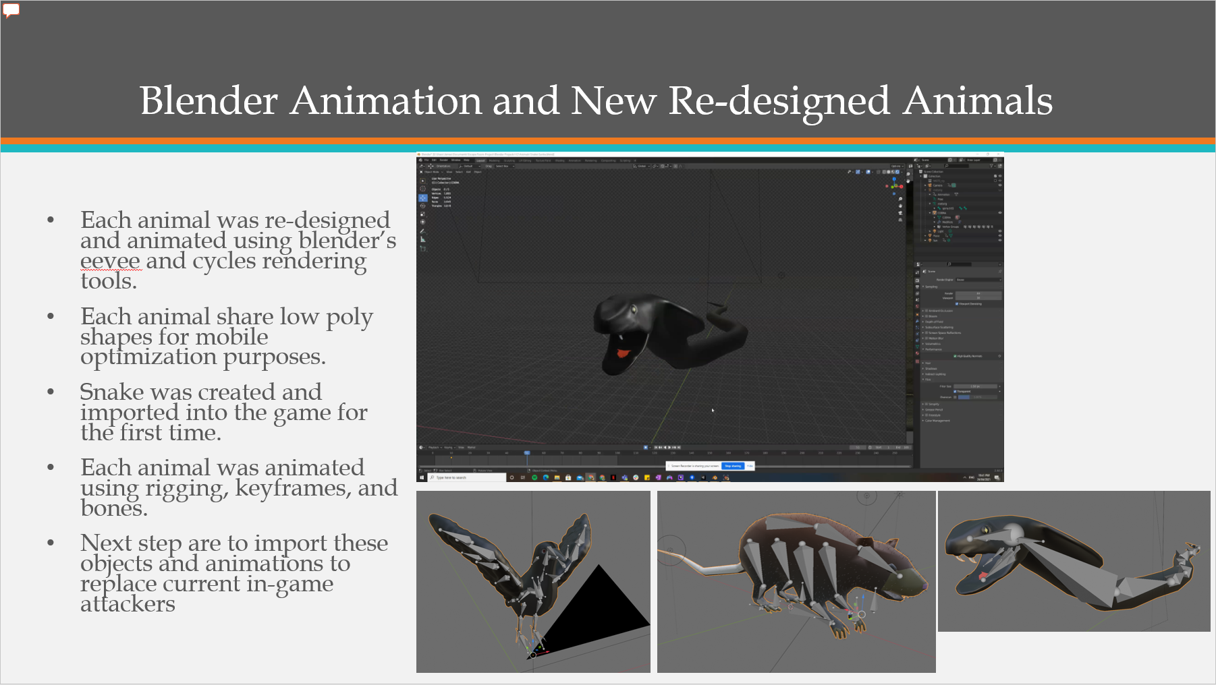

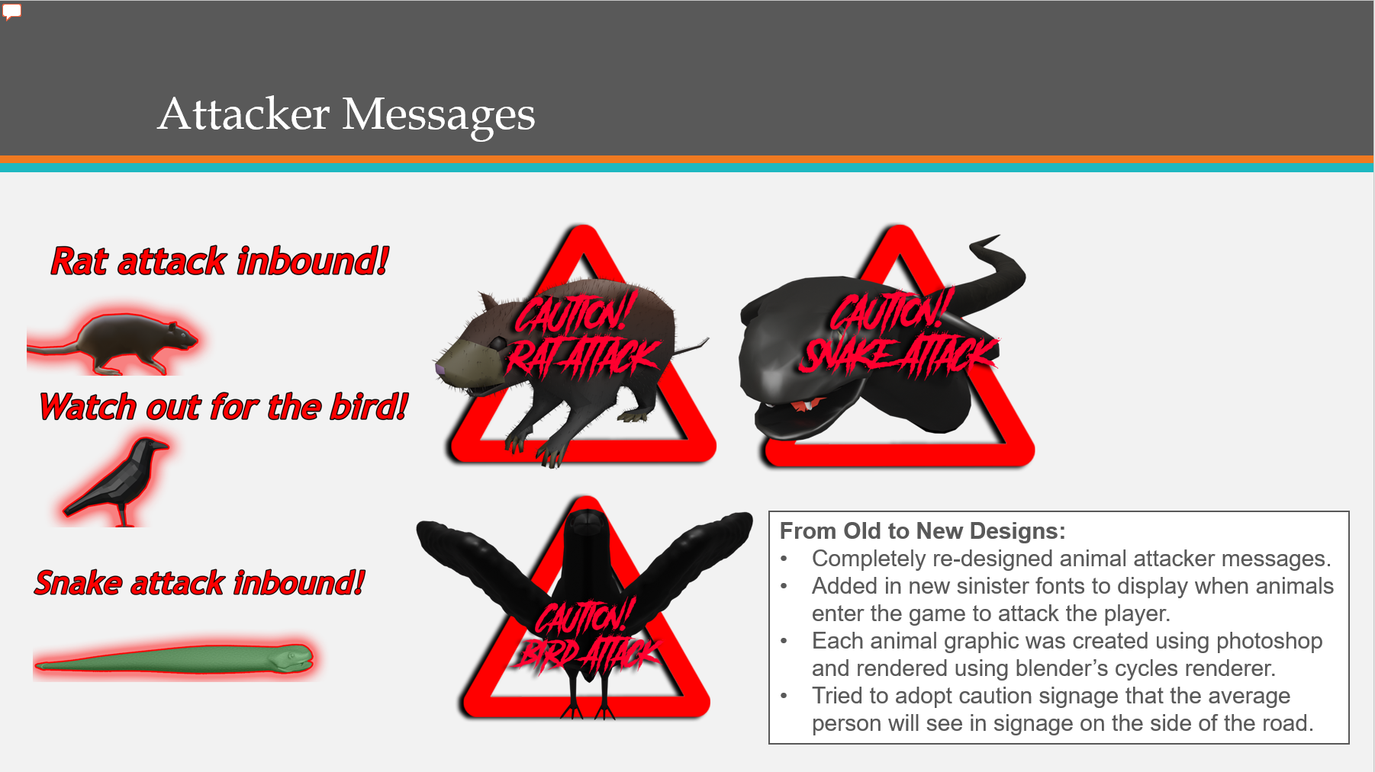

# Project management

* An example in trello of the Labels, members, comments, attachments, story points all assigned by myself.  
  